Bettie Enola Brown
October 4, 1963 – June 27, 2007

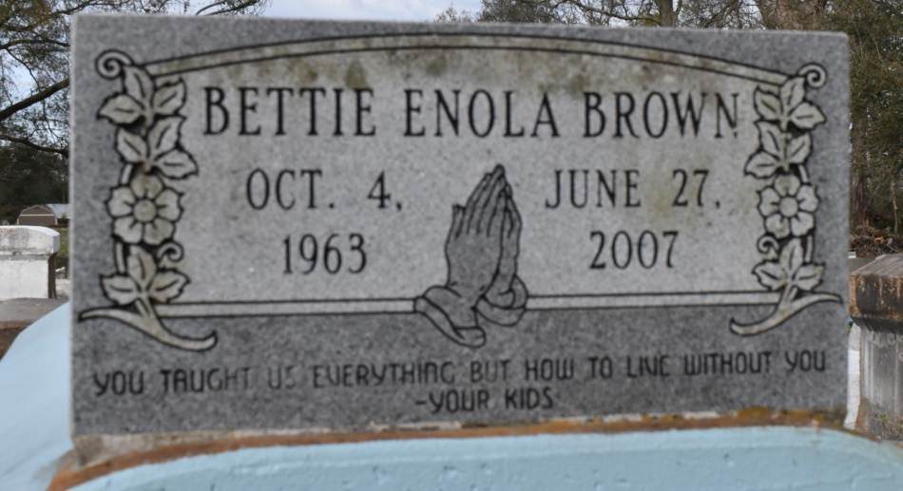

Bettie Enola Brown, age 43, a homemaker, passed away peacefully on Wednesday, June 27, 2007 in Lutcher, La. Daughter of George Washington Sr. and the late Barbaradine Johnson. Mother of Carl Thomas, Barbara, Latasha, and Carlous Brown. Sister of Donna Russell, Sandra Thomas, James Sr., Fred and Joshua Johnson. Devoted friend Charlie Joseph. Also survived by 3 grandchildren, and a host of aunts, uncles, nieces, nephew, sisters- and brothers-in-law, cousins, and friends. A native and resident of Lutcher, La.
Pastors, officers and members of Mt. Olive B.C. and all neighboring churches are invited to attend the Funeral Service on Thursday, July 5, 2007 at 11:00 a.m. at the above named church, 3143 Hwy. 642, Paulina, La. Rev. Elmo Lee, Pastor Officiating. Interment in Philippians Cemetery, Convent, La. (sic, buried in St. Mary Catholic Church Cemetery) Visitation at the church from 9:00 a.m. until service time.
Service entrusted to HOBSON BROWN FUNERAL HOME, Garyville, La. Information: (985) 535-2516
The Times-Picayune (New Orleans, LA)
July 4, 2007.

